

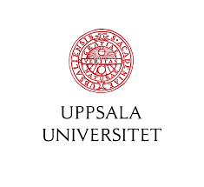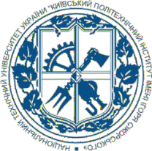

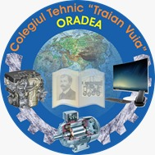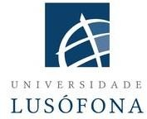https://www.ucasal.edu.ar/wp-content/uploads/2021/08/ucasal-logo.png

MINISTRY OF EDUCATION AND SCIENCE OF UKRAINE,

NATIONAL TECHNICAL UNIVERSITY OF **UKRAINE**

‘IGOR SIKORSKY KYIV POLYTECHNIC INSTITUTE’,

LUSOFONA UNIVERSITY (**PORTUGAL**), CATHOLIC UNIVERSITY OF SALTA (**ARGENTINA**), TECHNICAL COLLEGE "TRAIAN VUIA" (**ROMANIA**), AND UPPSALA UNIVERSITY (**SWEDEN**)

are pleased to invite all academics, scholars, researchers, and practitioners to participate in the **4th International Online Conference ‘Corpora and Discourse’** to be held **on November 26, 2024**.

The goal of the event is to present and discuss a wide range of scientific and practical achievements in **applied linguistics and language teaching**. Topics for submissioninclude:

* 1. Corpus investigation techniques.
  2. Сompiling specialised corpora.
  3. Computational linguistics and multi-modality.
  4. Psycholinguistics and sociolinguistics.
  5. Translation studies.
  6. Language teaching and learning.

The conference is **free** to attend, present and publish short abstracts.

**To participate:**

1. Complete the application form <https://shorturl.at/ROEqO> ;
2. Email your abstract in WORD at [corporadiscourse.kpi@gmail.com](mailto:corporadiscourse.kpi@gmail.com)

Language: **English**.

**APA style** should be used for references.

File name: *Surname_abstract.doc*; Times New Roman 14; line spacing 1,15; all margins 2 cm, paragraph 1.25 cm, distance before and after the paragraph 0.

For questions regarding submissions: [corporadiscourse.kpi@gmail.com](mailto:corporadiscourse.kpi@gmail.com)

# Final submission: November 11, 2024.

Participants will find their abstracts published at the conference website: <http://corpora.kamts1.kpi.ua/cad>. A Zoom link will be emailed to each participant before the event.

**ABSTRACT TEMPLATE**

LINGUISTIC ANALYSES OF THE ENGLISH LANGUAGE OF SCIENCE AND TECHNOLOGY THROUGH SPECIALIST CORPORA

Tetiana Maslova Senior Lecturer,

*National Technical University of Ukraine ‘Igor Sikorsky Kyiv Polytechnic Institute’*

In recent years corpus linguistics has offered new perspectives on linguistic analyses of academic and scientific discourse by examining and comparing the range of vocabulary, grammar patterns and rhetorical structures used either in the texts of different genres or across different sections within a research article…

… In mechanical engineering texts, on the other hand, there are more specialist vocabulary and a lower number of connectives (Crossley, Russell, Kyle, Romer, 2017). … As shown by Kanoksilapathams (2015), the step “Claiming centrality” is used rarely in civil engineering texts…

References

Crossley, S. A., Russell, D. R., Kyle, K., & Romer, U. (2017). Applying natural language processing tools to a student academic writing corpus: How large are disciplinary differences across science and engineering fields? *Journal of writing analytics*, *1*, 48-81. https://doi.org/[10.37514/JWA-J.2017.1.1.04](http://dx.doi.org/10.37514/JWA-J.2017.1.1.04)

Kanoksilapatham, B. (2015). Distinguishing textual features characterizing structural variation in research articles across three engineering sub-discipline corpora. *English for Specific Purposes*, *37*, 74-86.

<https://doi.org/10.1016/j.esp.2014.06.008>

Visit our website <http://kamts1.kpi.ua/> or follow us on Facebook <https://www.facebook.com/kamts1>to learn more about our events!